6 – sinf
II chorak
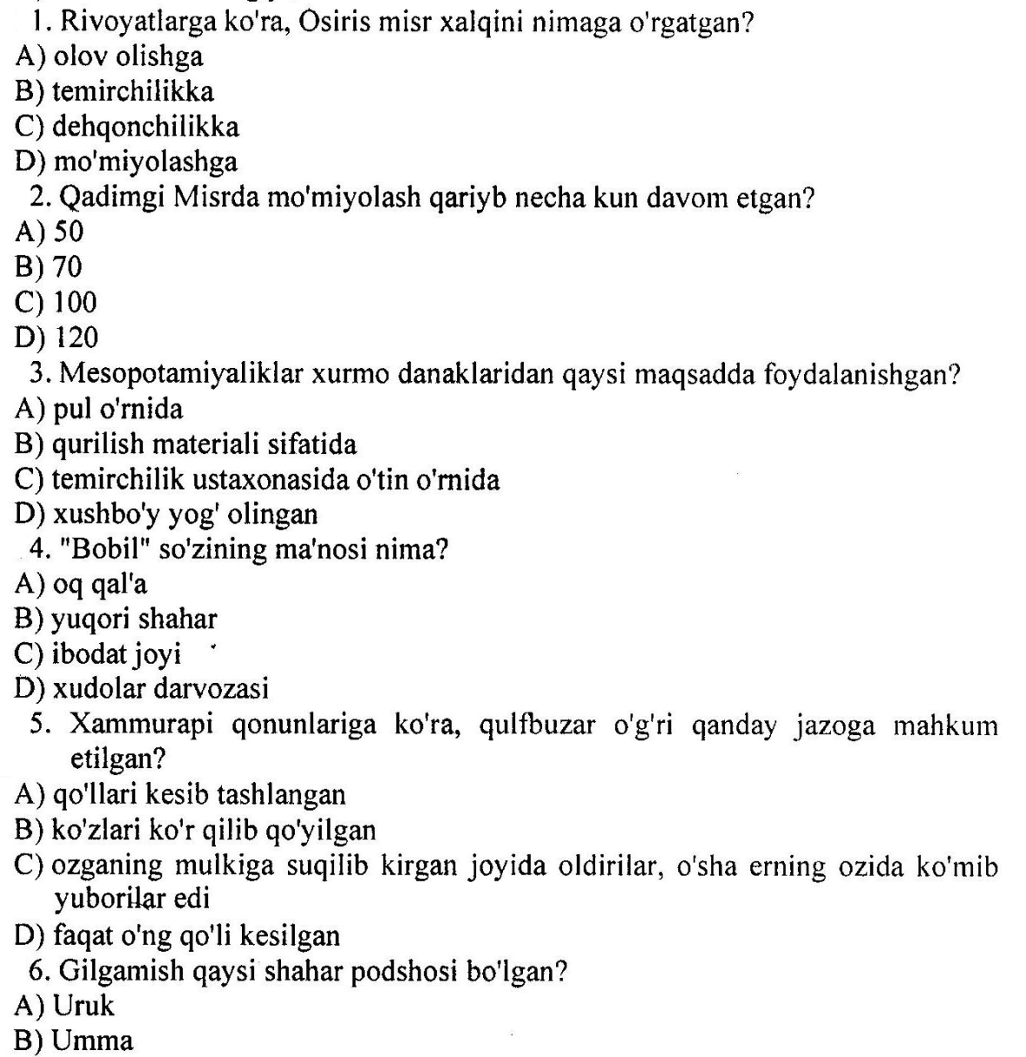
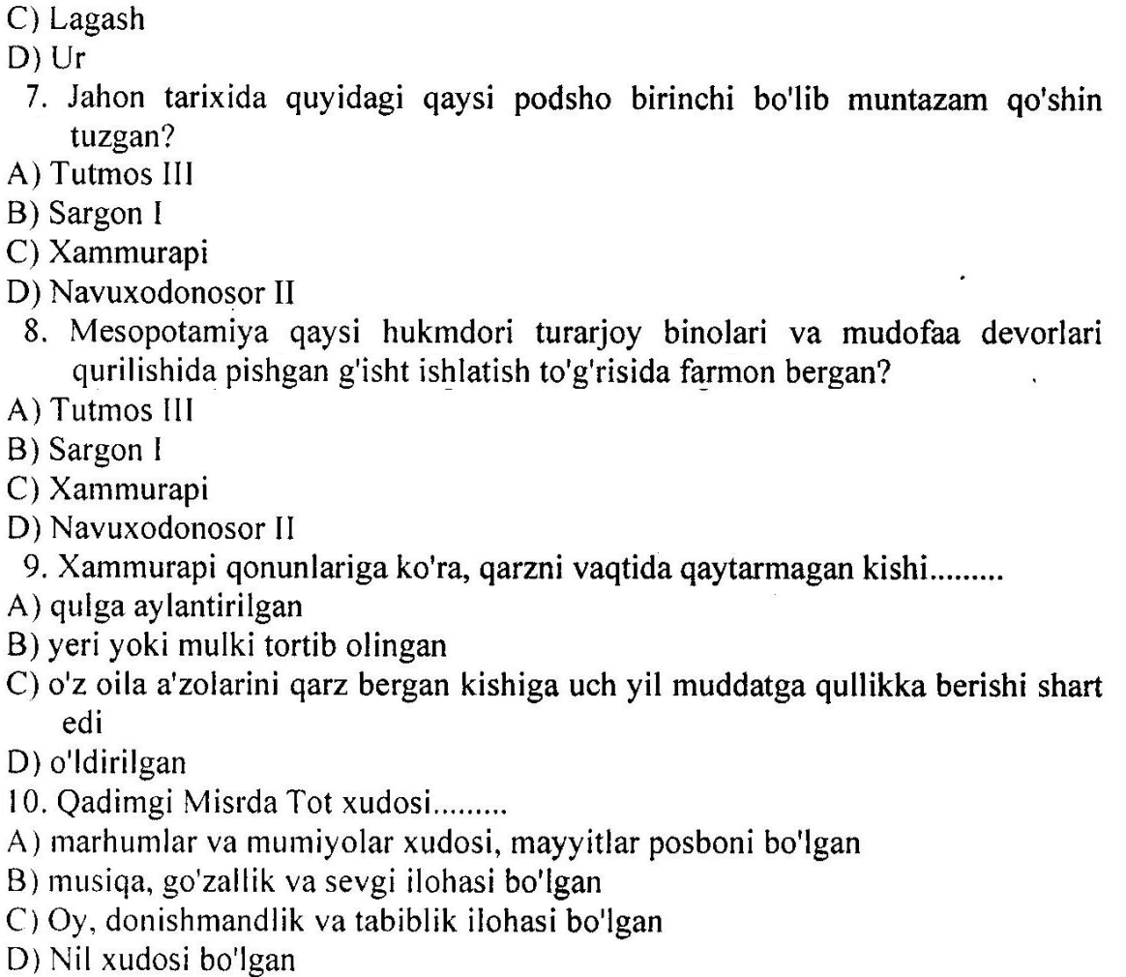

Test javoblari:
1 | 2 | 3 | 4 | 5 | 6 | 7 | 8 | 9 | 10
C | B | C | D | C | A | B | D | C | C

