10-sinf. Matematika. I chorak

1. Birorta ham elementga ega bo`lmagan to`plam
2. Chekli to`plam B. Bo`sh to`plam C. Qism to`plam D. cheksiz to`plam
3. A to`plamning hamma elementi B to`plamga tegishli bo`lsa nima bo`ladi
4. Chekli to`plam B. Bo`sh to`plam C. Qism to`plam D. cheksiz to`plam
5. A va B to`plamning birlashmasi qanday belgilanadi
6. $A∪B$ B. $A∩B$ C. $A∈B$ D. $A⊈B$
7. $A=\left\{2,3,5,7,11\right\}$, $B=\left\{2,4,6,8\right\}$, $A∩B$ ni toping
8. $\left\{2,4,6,8\right\}$ B. $\left\{2,3\right\}$ C. $\left\{2\right\}$ D. $\left\{∅\right\}$
9. Mulohoza gapning qaysi turiga bog`liq?
10. Buyruq gap B. So`roq gap C. Undov gap D. Darak gap
11. A $=True, B=False, C=True bo`lsa, ¬A$ ⋀B⋁C- ni toping

A. True B. False C. $\left\{∅\right\}$ D. 2

7. $P=\left\{4 sonining 10 va 30 orasidagi karralilari\right\}$

$Q=\left\{6 sonining 10 va 30 orasidagi karralilari\right\}$, $P∩Q-?$

1. $\left\{12,20\right\}$ B. $\left\{12,16,24\right\}$ C. $\left\{12,24\right\}$ D. $\left\{12,20, 30\right\}$
2. Dizyunksiya qanday belgilanadi?
3. V B. $⋀$ C. $¬$ D. $∈$
4. (p $⇒q)⋀(q⇒p)$ nima deyiladi
5. Konyunksiya B. Dizyunksiya C. Implikatsiya D. Ekvivalensiya
6. p $⇒q$ mulohozaning konversiyasi nima?
7. $q⇒p$ B. ¬ $q⇒p$ C. ¬ $q⇒¬p$ D. ¬p⇒q
8. Umumiylik kvantori qanday belgilanadi
9. $∀$ B. $∃$ C. $∋$ D. $∈$
10. Ko`pchilik tomonidan qabul qilingan an’anaviy fikrga zid mulohoza
11. Predikat B. Paradoks C. Kvantor D. Sofizm
12. 8000000 so`m yiliga 7% stavkasida 18 oyga olingan bo`lsa, foiz to`lovini hisoblang
13. 840000 so`m B. 560000 so`m C. 56000 so`m D. 84000 so`m
14. 1000 AQSH dollori murakkab foiz stavkasi yillik 6% bilan 2 yilga olingan bo`lsa, daromad qancha bo`ladi?
15. 1020$ B. 1123$ C. 1030$ D. 1120$
16. Mijoz bankka 5000$ oylik foiz stavkasi 8% bilan qo`ydi 24000$ foyda olish uchun qancha vaqt kerak?
17. 4 yil B. 15 yil C. 6 yil D. 5 yil
18. Ataylab chiqarilgan noto`g`ri xulosa
19. Paradoks B. Kvantor C. Sofizm D. Predikat
20. Mulohozalarda o`zgaruvchilar o`rniga aniq qiymat qo`yilsa, hosil bo`ladigan mulohoza
21. Paradoks B. Kvantor C. Sofizm D. Predikat
22. Fikrda bir butun ko`plik deb to`plamga ta’rif bergan matematik kim?
23. Beruniy B. Kantor C. Qobilov D. Pifagor
24. 4 soni D to`plam elementi qanday yoziladi
25. $4∈D$ B. $4∃D$ C. $4→D$ D. $4⊈D$
26. P= $\left\{1,3,4\right\}$ Q= $\left\{2,5,6\right\}$ $P∩Q-?$
27. $\left\{1,2,3,4,5,6\right\}$ B. $\left\{1,3,6\right\}$ C. $\left\{1,3,4\right\}$ D. $\left\{∅\right\}$

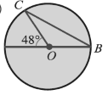BOC uchburchak burchakalrini toping

1. 480, 480, 840
2. 240, 1320, 240
3. 420, 900, 480
4. 480, 320, 200
5. Uchburchakning uchlari radiuslari 6 sm. 7 sm, 8 sm bo`lgan va juft-jufti bilan urinadigan uchta aylana markazlarida yotibdi. Bu uchburchak perimetrini toping
6. 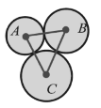28 sm
7. 29 sm
8. 27 sm
9. 42 sm
10. $A∩B$ ni toping

1) 2) 3) 4)

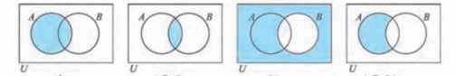

1. 1 B. 2 C. 3 D. 4
2. $P∪Q$ to`plamning nechta elementi bor

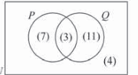

1. 25 ta
2. 24 ta
3. 28 ta
4. 21 ta

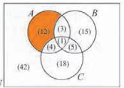

1. $A∪B∪C va A∩B$ to`plamning elementlari sonini toping
2. 58 va 4
3. 45 va 13
4. 57 va 4
5. 46 va 12

10-sinf. Matematika . II chorak

|  |  |
| --- | --- |
| 1. | Teng kuchli tenglamalarni ko‘rsating:  1) 10*x*=8; 2) 6*x*−4=*x*; 3) *x2*+2*x*+18=0.  A)1 va 3; B) 2 va 3; C) 1 va 2; D) hammasi. |
| 2. | Tenglamani katta ildizini toping: (*x*−5)(*x*+4)(*x−*11)=0.  A)−4; B) 5; C) 16; D)11. |
| 3. | Bikvadrat tenglamaning ildizlari yig‘indisini toping: 3*x4*+8*x2*−11=0  A) 1; B) −1; C) 0; D) 11/3. |
| 4. | Tenglamalar sistemasining nechta yechimi bor? $\left\{\begin{aligned}x^{2}+y^{2}=10 \\ xy=3\end{aligned}\right.$ A) 1; B) 2; C) 3; D) 4. |
| 5. | Tenglamani yeching: $\sqrt{5x+9}$.=7  A) 2; B) 4; C) 6; D) 8. |
| 6. | Tenglamalar sistemasining nechta yechimi bor? $\left\{\begin{aligned}\sqrt{x}+\sqrt{y}=11 \\ \sqrt{xy}=30\end{aligned}\right.$ A) 1; B) 2; C) 3; D) 4. |
| 7. | Tekislikda *A*(3;1) va *B*(7;3) nuqtalardan teng uzoqlikda joylashgan *C*(5;*x*) nuqtani toping. nuqtani toping;  A) (5;2); B) (5;3); C) (4;2); D) (4;3). |
| 8. | Tenglamani yeching 3∙5x+3−5x+2−2∙5x+1=68.  A) 1; B) 2; C) −1; D) 0. |
| 9. | Tenglamaning butun ildizlarini toping ${11}^{3x^{2}+23}={11}^{x^{2}+25x}$ A) 1; B) −1; C) 2; D) 1 va −1. |
| 10. | Qaysidir davlat aholisi soni yiliga 3% kamaysa necha yildan so‘ng 20% kamayadikamakkamayadi?  A) 6; B) 2; C) 8; D) 4. |
| 11 | Tengsizlikni yeching: (*x2*+6*x*−7)(*x2*+*x*+1)⩽0.  A) [−7;1]; B) [−7;−1]; C) [7;−1]; D) [7;1]. |
| 12. | Tengsizlikni nechta butun yechimi bor? |*x−*2| ⩽5.  A) 10; B) 11; C) 8; D) 9. |
| 13. | Tengsizlikni yeching: |4*x−*1| ⩽−2.  A) [−7;1]; B) [−7;−1]; C) [7;−1]; D) yechimi yo‘q. |
| 14. | Tengsizlikni nechta butun yechimi bor?   1. 3; B) 4; C) 5; D) 6. |

15. Radiusi 3 sm ga teng shar sirtini yuzini toping;

A) B) C) D)

16. Fazoning ixtiyoriy nuqtasidan berilgan tekislikka perpendikulyar nechta to`g`ri chiziq

o`tkazish mumkin ?

1. Cheksiz ko`p B) Bitta C) Ikkita D) Uchta

17. Uchinchi tekislikka parallel ikki tekislik o`zaro qanday joylashadi?

A) Perpendikular B) Parallel C) Ayqash D) Ustma-ust

18. Silindrning to`la sirti formulasini toping

1. B) C)

D)

19. Quyidagi burchaklarning qaysilari qo`shni bo`lishi mumkin?

1) 180 2) 720 3) 1280 4) 620 5) 280 6)1080 7) 380

A) 1 va 2 B) 2 va 6 C) 3 va 4 D) 2 va 5

20. Agar teng yonli uchburchak burchaklari 3:4:3 nisbatda bo`lsa, uning uchuning bissektrisasi

va yon tomomni orasidagi burchakni toping

1. 180 B) 720 C) 360 D) 600

21. 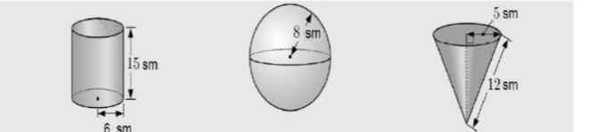

Yuqoridagi shakllarning qaysi birining to`la sirtining yuzi $267 {sm}^{2}$  ga teng

1. Silindr B) Shar C) Konus D) Teng emas

22 Quyidagi shakllarning qaysilari ko`pyoq bo`ladi?

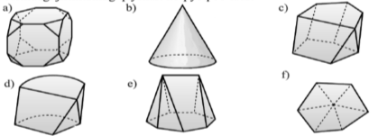

1. a,c,e,f B) c,e C) a,c,e D) a,c,d,e,f

23. Bo`sh katakning qiymatini toping

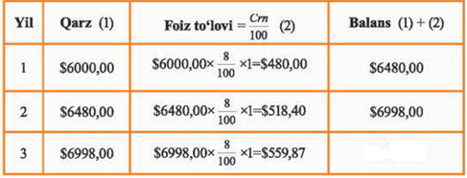

1. 7435,27$ B) 7556,27$ C) 7557,87$ D) 7559,27$

24. Kesimida fazoviy to`rtburchak hosil bo`lgan shakllar qaysilar

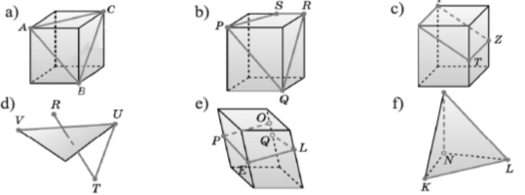

1. b,c B) b,c,e C) a,b,c,e D) a,b,e,f

25. Shaklning to`la sirtini toping

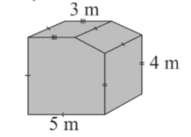

$\left(133+5\sqrt{5}\right) m^{2}$

$\left(132+5\sqrt{5}\right) m^{2}$

$\left(133+\sqrt{5}\right) m^{2}$

$\left(134+5\sqrt{5}\right) m^{2}$

10-sinf. Matematika. III chorak.

1. Agar munosabatda birinchi koordinatasi teng bo`lgan ikkita turli nuqta mavjud bo`lmasa, bu munosabat …. deyiladi
2. Qiymat B) Argument C) Funksiya D) To`plam
3. Quyidagi munosabatlardan qaysilari funksiya bo`ladi
$$1) \left\{\left(1,3\right), \left(2,3\right), \left(3,5\right), (4,6)\right\}; 2)\left\{\left(1,3\right), \left(3,3\right), \left(1,5\right), (4,6)\right\};$$

$$3) \left\{\left(0,0\right), \left(0,3\right), \left(3,0\right), (3,6)\right\}; 4)\left\{\left(7,3\right), \left(6,3\right), \left(5,5\right), (4,6)\right\};$$

4. 1 va 2 B) 2 va 3 C) 2 va 4 D) 1 va 4
5. Agar $f:x→3x-x^{2}+2$ bo`lsa $f(3)$ ni toping
6. 3 B) 0 C) 2 D) 16
7. $y=x^{2}+6x+4$ parabolaning uchini toping
8. (-3,-5) B) (3,5) C) (-3,5) D) (3,-5)
9. y=(x-2)(x-6) parabolaning simmetriya o`qini toping
10. x=-4 B) x=4 C) x=3 D) x=0
11. 2100 ni radianda ifodalang
12. $\frac{5π}{4}$ B) $\frac{7π}{6}$ C) $\frac{11π}{6}$ D) $\frac{7π}{4}$
13. $y=sin4x$ funksiyaning davrini aniqlang
14. 3600 B) 7200 C) 1800 D) 900
15. ni hisobalng

$A)-\frac{π}{2}$ B) $-\frac{π}{3}$ C)- $\frac{π}{6}$ D) $π$

1. $4\cos^{2}x-8cosx-3=0$ tenglamani yeching
2. $x=±\arccos\left(1-\frac{\sqrt{7}}{2}\right)+πn$ B) $x=±\arccos\left(1-\frac{\sqrt{7}}{2}\right)+2πn$ C) $x=\arcsin\left(1-\frac{\sqrt{7}}{2}\right)+πn$ D) $x=±\arccos\left(1-\frac{\sqrt{7}}{2}\right)+4πn$
3. $\left\{\begin{aligned}x=4 sint \\ y=3 cost\end{aligned}\right.$ parametrik ko`rinishda berilgan funksiya grafigi qanday chiziq bo`ladi?
4. Parabola B) To`g`ri chiziq C) Ellips D) Giperbola
5. Fazoda bitta tekislikda yotmaydigan to`g`ri chiziqlar ….. deyiladi.
6. Ayqash to`g`ri chiziqlar. B) Parallel to`g`ri chiziqlar C) Perpendikular to`g`ri chiziqlar

D) kesishuvchi to`g`ri chiziqlar

1. a va b to`g`ri chiziqlar bitta tekislikda yotadi. Bu to`g`ri chiziqlarning mumkin bo`lgan o`zaro joylashishini ko`rsating

1) a va b parallel; 2) a va b kesishadi; 3) a va b kesishmaydi; 4) a va b ayqash;

5) a va b parallel emas.

A) 1,2,4 B) 2,3,5 C) 1,2,3,5 D) hammasi

13. To‘g‘ri tasdiqni tanlang:

1. Fazoda to‘g‘ri chiziqda yotmagan nuqtadan bu to‘g‘ri chiziqqa parallel o`tkazish mumkin emas;
2. uchinchi to‘g‘ri chiziqqa parallel to‘g‘ri chiziqlar bitta nuqtada kesishadi;
3. agar to‘g‘ri chiziqning ikki nuqtasi tekislikka tegishli bo‘lsa, to‘gri chiziqning o`zi ham tekislikka tegishli bo`ladi;
4. to‘g‘ri chiziq va unda yotmagan nuqtadan ikkita har xil tekislik o‘tkazish mumkin;

14.Qaysi biri katta? $2^{-\sqrt{3}} va 3^{-\sqrt{3}}$

A) $2^{-\sqrt{3}}$ B) $3^{-\sqrt{3}}$ C) Bular teng

15. Agar y=sin bx b>0 uchun funksiyaning davri 21600 bo`lsa, b ni toping

A) 6 B) 1/6 C) 4 D) 1/5

16. .

A) B) 16 C) -4 D) 4

17. y=-3x2+4x-5 parabolaning simmetriya o`qini toping

A) B) C) D)

18. y= funksiyaning aniqlanish sohasini toping

A) B) C) D)

19. ni hisoblang

A) B) C) D)

20. Tengsizlikni yeching:

A) B) C) D)

21. Quyidagilarning qaysilari funksiya bo`ladi?

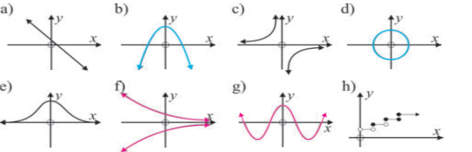

A) a,b,c,e ,g B) a,b,g C) b,c,e D) a,b,c,e,g,h

22. Funksiyaning o`sish oralig`ini toping

1. 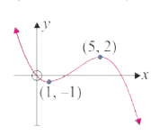(1;5)
2. (-1;5)
3. (-1;2)
4. (1;2)

23 ABCuchburchak $α$ tekislikni B1 va C1 nuqtalarda kesib o‘tadi (4- rasm). Agar

AB1: BB1 =3:2, BC =15 sm, BCllB1C1 bo‘lsa, B1C1 kesmaning uzunligini toping.

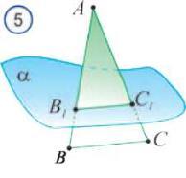

. A) 6

1. 9
2. 12
3. 8

24. Berilgan parallelepipedning berilgan yoqlarigdan qaysi biri ABCD yog`iga parallel bo`ladi?

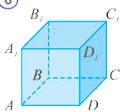

1. ABB1A1
2. CDD1C1
3. B1C1CB
4. A1B1C1D1

25. Qaysi kesmalar proporsional

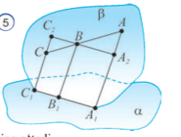

1. AB:BC=AB:BC2
2. AB:BC=A1B1:B1C1
3. AB:BC=AA2:A2A1
4. AB:BC=C2C:CC1

10-sinf. Matematika

|  |  |
| --- | --- |
|  | Diagonallari 10 va 36 bo`lgan rombning yuzini toping |
|  |  |
|  | A)360 B)180 C)720 D)160 |
|  |  |
|  | geometrik progressiyada  va .  ni toping. |
|  |  |
|  | A) B) C) D) |
|  |  |
|  | Yig`indini toping: (3+7i)+(-5+4i)=. |
|  |  |
|  | A)-3+11i B)4-2i C)2+11i D)-2+11i |
|  |  |
|  | tenglamani yeching. |
|  |  |
|  | A) B) C) D) |
|  |  |
|  | tengsizlikni yeching. |
|  |  |
|  | A) B) C)  D) |
|  |  |
|  | Birinichi kuni ish normasining  qismi bajarildi. Ikkinchi kuni birinchi kunda bajarilgan ishning  qismicha ko’p ish bajarildi. Shu ikki kunda qancha ish normasi bajarilgan? |
|  |  |
|  | A) B) C) D) |
|  |  |
|  | Bo`linmani toping: $\frac{2+3i}{4-3i}$ |
|  |  |
|  | A) $\frac{1}{25}+\frac{18}{25}i$ B)10 i C) $-\frac{1}{25}+\frac{18}{25}i$ D)12+4i |
|  |  |
|  | Hisoblang: $\frac{lg2+lg162}{2lg3+lg9}$ |
|  |  |
|  | A) 3 B) 2 C) D) |
|  |  |
|  | tengsizlikni yeching. |
|  |  |
|  | A) B) C) D) |
|  |  |
|  | Agar kamayuvchi 16 ta va ayriluvchi 20 ta ortirilsa, ayirma qanday o’zgaradi? |
|  |  |
|  | A)4 ta kamayadi B)36 ta ortadi  C)36 ta kamayadi D)4 ta ortadi |
|  |  |
|  | tengsizlikni eching. |
|  |  |
|  | A) B) C)  D) |
|  |  |
|  | image170Teng yonli ABC va ADC uchburchakalr tekisliklari perpendikulyar. AC ularning umumiy asosi, BK kesma ABC uchburchak medianasi, agar BK=8, DK=15 bo`lsa, BD kesma uzunligini toping |
|  |  |
|  | A) B) 17 C) D) |
|  |  |
|  | Agar proyeksiya yo`nalishi proyeksiyalash tekisligiga perpendikulyar bo`lsa, bunday parallel proyeksiyalash … proyeksiyalash deyiladi |
|  |  |
|  | A) teskari B) parallel C) gomotetiya D) ortogonal |
|  |  |
|  | ni hisoblang. A)3 B) C)2 D) |
|  | Arifmetik progressiya uchun quyidagi formulalardan qaysilari to’g’ri? |
|  |  |
|  | A) B) C) hammasi D) |
|  |  |
|  | funktsiyaning aniqlanish sohasini toping. |
|  |  |
|  | A) B) C)  D) E) |
|  |  |
|  | ni qisqartiring. |
|  |  |
|  | A) B) C) D) |
|  |  |
|  | tengsizlik nechta butun yechimga ega? |
|  |  |
|  | A) B) C) D)5 |
|  |  |
|  | tengsizlikni yeching. |
|  |  |
|  | A) B)  C) D) |
|  |  |

1. $\log_{2}\left(x+2\right)=2$ tenglamani yeching
2. AB, AC, AD juft-jufti bilan perpendikulyar, AB=3 sm, BC=7 sm, AD=1,5 sm bo`lsa, CD-?
3. Quyidagi rasmlarning qaysilarida tekislik va og`ma orasidagi $α$ burchak to`g`ri belgilangan

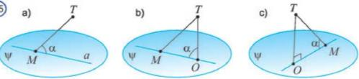

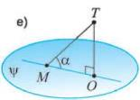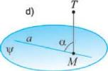

1. SABCD ko`pyoqning $α$ tekislikdagi orthogonal proyeksiyasini toping



1) 2) 3) 4)



1. Funksiyaning davri nechaga teng

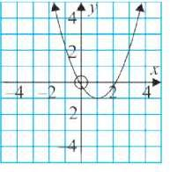

1. O`sish va kamayish oraliqlarini toping

Kalitlar

|  |  |  |  |  |  |  |  |  |  |  |  |  |  |  |  |  |  |  |
| --- | --- | --- | --- | --- | --- | --- | --- | --- | --- | --- | --- | --- | --- | --- | --- | --- | --- | --- |
| savol | 1 | 2 | 3 | 4 | 5 | 6 | 7 | 8 | 9 | 10 | 11 | 12 | 13 | 14 | 15 | 16 | 17 | 18 |
| javob | B | D | D | A | D | A | C | B | A | A | A | B | D | C | A | B | D | D |

19. 

20. x=2

21. 6,5

22. c,e

23. 4

24. 1200

25. x>1 o`suvchi, x<1 kamayuvchi